Annex Q: Landscape profiles of project’s targeted agricultural landscapes.

The current annex presents briefly the project’s two targeted agricultural landscapes in Longfei (Bishan District Chongqing) and in Hulu (Wenchang City Hainan) in two sub-annexes:

Annex Q-1: Project targeted agricultural landscape in Chongqing.
Annex Q-2: Project targeted agricultural landscape in Hainan.

Annex Q-1: Project targeted agricultural landscape in Chongqing.

Bishan District

Main Features
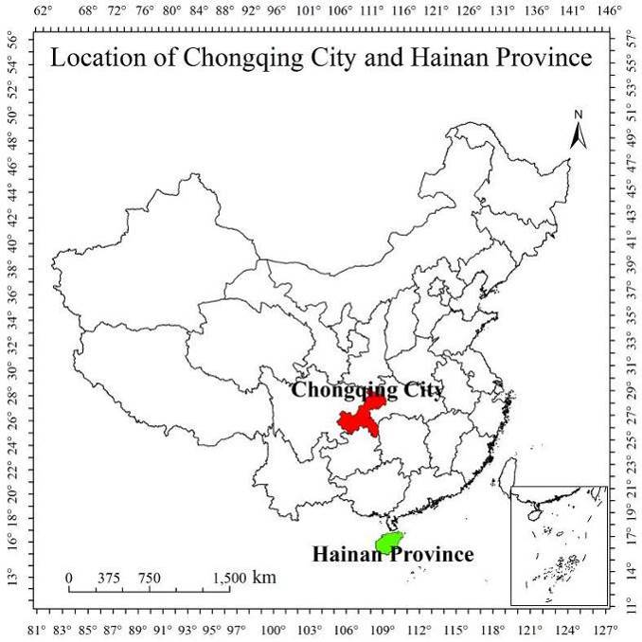
Bishan District (map 2) is located in the South-West part of Chongqing Municipality (Location: E 106°15′14″~106°6′58″;N 29°20′2″～29°50′32″) and covers an area of 914.55 square kilometers, but due to the hilly topography of the district (43.6%) it only has approximately 28,56 % of agricultural land (391,770 mu). Bishan’s altitude is 500~810 meters. Its located in the subtropical humid monsoon climate zone. The mean annual precipitation is 1065 millimeters and the annual average temperature is 18.0°C. Bishan District has within the last years rapidly developed its vegetables and fruit industry and is now one of four vegetable counties in Chongqing, with more than 50 vegetable species grown on hundred thousand mu. The overall grape-growing area is 35,000 mu with an annual output of around 45,000 tons of “national high quality” grapes. In addition, large areas for seedling production and growing of fruit trees are planned.
Map 1: Chongqing's location in China
Figure 1: Location of Chongqing in China
Major IAS
Many of the main Alien Invasive Species which are found in Chongqing (Table 2) are also found in Bishan District such as alligator weed Alternanthera philoxeroides, water hyacinth Eichhornia crassipes and golden apple snail Pomacea canaliculata. Within Bishan district farmland, orchard garden, fishpond and channels A. philoxeroides affects 139,000 mu and the area impacted by P. canaliculata is 32,000 mu.
Map 2: Bishan District's location in Chongqing

Public governance and institutional framework for IAS management
To improve the prevention, control and management of IAS, Chongqing has established an “IAS Management Office” as well as has issued “Chongqing Regulations on Plant Quarantine” and published “Chongqing Emergency Response Plan to Major Agricultural Pests and IAS (YNF [2006] No. 561). IAS is also mentioned in the Chongqing Biodiversity Strategy and Action Plan as well as in the 13 five-year agricultural and environmental plans.

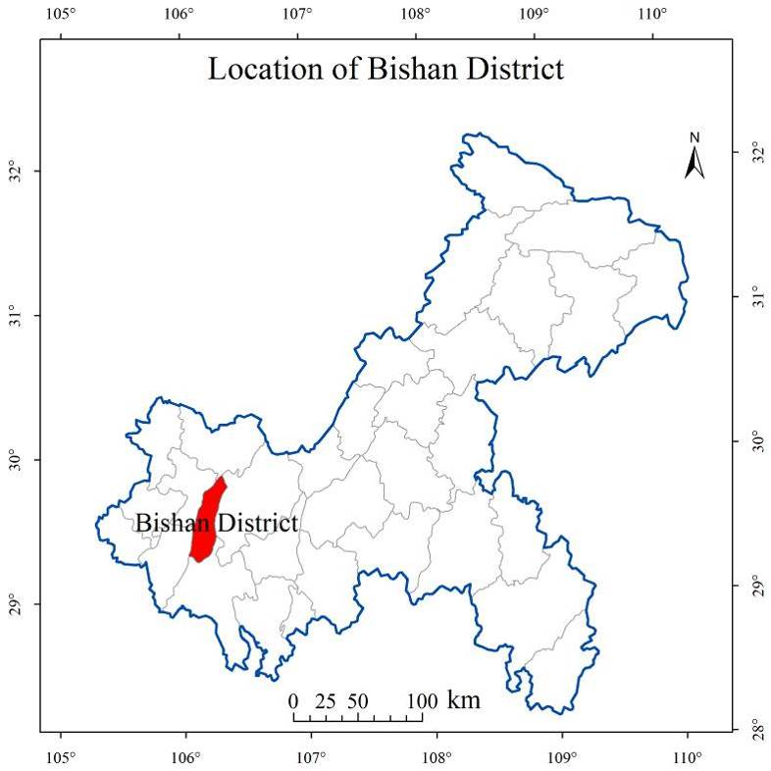
Overall Chongqing Agricultural Ecology and Resources Protection Station (CAERPS) is responsible for IAS Management within the Municipality, including organizing trainings of government staff and local farmers. CAERPS cooperates with other government entities working on ISA Management such as the Bureau of Ecology and Environment of Chongqing. In Bishan the implementation of IAS Management is led by the Bishan District Agricultural Product Quality and Environmental Monitoring Station (BDAPQEMS), which has one specialized IAS staff on its staff roster. As with CAERPS, BDAPQEMS is responsible for providing training within the district and it works together with other local entities (see table 1). The Agricultural Technology Center of Daxing, is in a similar way, the responsible party for IAS Management and training within the township. The practical implementation of IAS Management is however, left to the village level governments/authorities, which will engage the local farmers in projects/programs (financed through funding provided from higher levels). These interventions are different from the day-to-day interventions performed by the local farmers in their regular work on the fields which includes weed and pest management.
Figure 2: Location of Bishan district in Chongqing

Table 1: Roles and responsibilities government departments
Departments / bureaus / Institution | Roles and responsibilities
Chongqing Agriculture Committee (CAC) | The Chongqing Agriculture Committee is the municipality's equivalent to MARA and undertakes many of the same functions but at provincial level. The Agriculture Committee is the provincial lead with regard to IAS prevention, control and management.
The People's Government of Chongqing, Bishan District (PGCBD) | The People's Government of Chongqing, Bishan District encompasses all of the local governmental departments and undertakes the day to day governing of the city and the implementation of the city’s projects and programs. People's Government of Wenchang City will be responsible for project organization, implementation and daily regulation at local area, and will provide support to the IAS project.
Bishan Agricultural Technology Extension Center (BATEC) | The Bishan Agricultural Technology Extension Center is in charge of providing agricultural production service and technical promotion of Bishan District and is responsible for the implementation of IAS prevention, control and management at local level.
Bishan District Forestry Bureau (BDFB) | As part of the Bishan District Government the Bishan Forestry Bureau is in charge of forestry management in Bishan District including the implementation of IAS prevention, control and management at local level within the forested areas of Bishan.
Bishan District Environmental Protection Bureau (BDEPB) | As part of the Bishan District Government the Bishan Environmental Protection Bureau is in charge of ecological environment protection in Bishan District and is responsible for the implementation of IAS prevention, control and management within protected areas and other conservation areas.
Agricultural Technology Center of Daxing Town | Being responsible for implementation of IAS prevention and control work in Daxing town.
Longfei Village of Daxing Town, Bishan District | Being responsible for the implementation of IAS control and prevention at village level.

IAS management
Although the Bishan District is implementing municipal plans and programs (as relevant) within its area, no district IAS management system is in place and no specific IAS Management planning has been formulated. In addition, no county level IAS list is available providing for a poor information basis to support any future planning and management processes within the district. For some of the more aggressive IAS, such as alligator weed, golden apple snail and water hyacinth, investigations covering the whole district have been carried out in recent years. These investigations, however, are most often based on a present/non-present methodology at village or field level. Also, the investigations are undertaken every 3-5 years on a rolling basis and are not “real-time” sensitive.

Table 2: Encroachment data of key IAS in Chongqing Municipality
Key IAS found in Chongqing Municipality | IAS affected area in  Chongqing (mu) | IAS affected area in  Bishan (mu)
Alligator weed Alternanthera philoxeroides (Mart.) Griseb. | 2,583,000 | 50,000
White horseweed Conyza sumatrensis (Retz.) | 470,000 | 12,000
Golden apple snail Pomacea canaliculata (Lamarck) | 374,000 | 10,000
Rice water weevil Lissorbqptrus oryzqphilus (Kuschel) | 163,000 | 3,500
Oriental Fruit Fly Bactrocera dorsalis (Hendel) | 150,000 | 12,000
Water hyacinth Eichhornia crassipes (Martius) Solms-Laubach | 40,000 | 2,000
Red Swamp Crayfish Procambarus clarkii | 30,000 | 200
Crofton weed Eupatorium adenophora | 20,000 | 0
Total | 3,380,000 | 89,700

Longfei agricultural landscape

Main Features
The project’s targeted agricultural landscape in Bishan District, Chongqing is located around the Longfei village. The Longfei village (map 3) itself is located in the Daxing township in the Meijiang Mountains, about 50 kilometers from Chongqing City and about 15 kilometers from Bishan District center at an average elevation of 300 meters. It is a hilly terrain with a total of 3,000 mu of cultivated land. Garden/farming plots account for 1,200 mu, woodland for 5,600 mu (including areas used for orchards and wine) equating to an approximate household land area of 4.3 mu. Longfei Village has a total of 1196 households, and a population of 3399 people, whose average annual net income is 11,500 RMB (please see Annex F and K for further socio/economic and gender related data). Within the agricultural landscape the main crop and produce are corn (app 2160 mu), vegetables (app 1,920 mu), wild rice stem Zizania latifolia (Jiao Bai) (app. 1,440 mu), Chinese mustard brassica juncea var. tumida, as well as orah mandarins (app 1,000 mu) and other fruits and grapes. The reported average yield of corn, wild rice stem, green vegetables and fruits are 150, 80, 100 and 120 kg/mu respectively.
Map 3: Longfei village's location in Chongqing

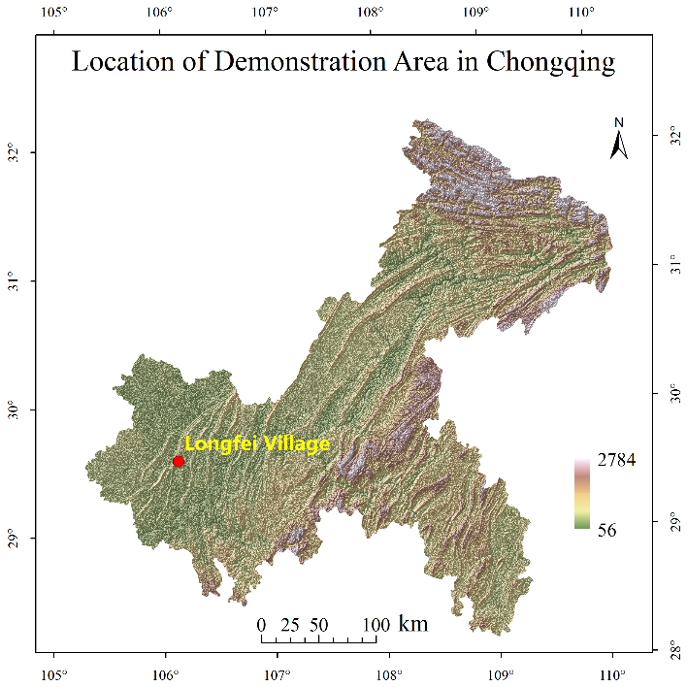
Major IAS and current management approaches
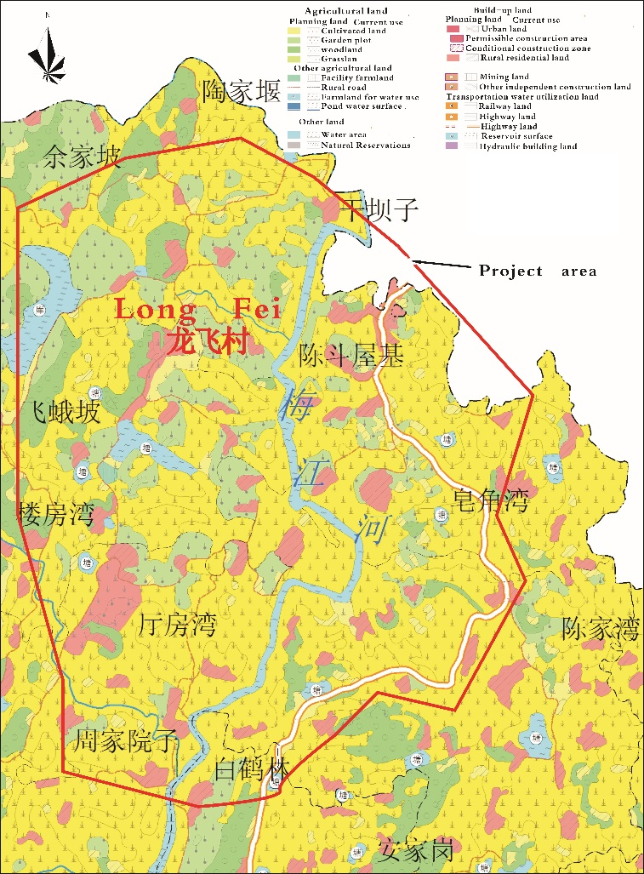
In Longfei village the main IAS is alligator weed, which occurs in large areas both within the field system, as well as on public land and common-used areas. Alligator weed occurs on about 3,800 mu, and while being controlled, management measures to eradicate the weed are ineffective, resulting in a rapid recolonization of cleared areas. A key component in the lack of effective removal of the alligator weed is that farmers focus on the weed in their fields (on equal footing with other weeds) and do not engage, to any larger extent, in combatting alligator weed in the common-use areas, outside the farm plots’ immediate vicinity. Also, there is no coordination among farmers in their tackling the spread of the alligator weed. To control alligator weed farmers generally use pesticide spraying, which is applied to the fields four times a year at a total cost of approximately 112 RMB/mu per year, leaving a potential annual spraying cost for the affected areas of 425,600 RMB per year, rendering an average annual village household cost of approximately 355 RMB. Within the 11,000 ha large project target agricultural landscape around Hulu village alligator weed and golden apple snail can be found on respectively 5,000 and 1,000 ha. In addition, wild rice stem and citrus are being cultivated on 1,800 ha of land
Figure 4: Agricultural landscape around Longfei village
Figure 3: Location of Longfei village in Bishan district.

The area invaded by golden apple snail is proportionally smaller than that of alligator weed, but nonetheless, with its 400 mu it affects 28% of the areas used for growing wild rice stem. As in Hulu village (Hainan), within the village there are generally three commonly used methods to combat the golden apple snail. One is to have free ranging ducks forage on snail eggs and young snails. Secondly, pomelo oil is used to spray over the water, and although this method is recognized to only have limited effect, it is used as a precautionary measure regardless. Finally, the villagers, in cases of heavy infestation, mechanically (by hand) remove the snails.
None of these generally used methods are aimed at eradicating the IAS, but merely to control its numbers and keep them at an acceptable level.

Economic losses from IAS encroachment
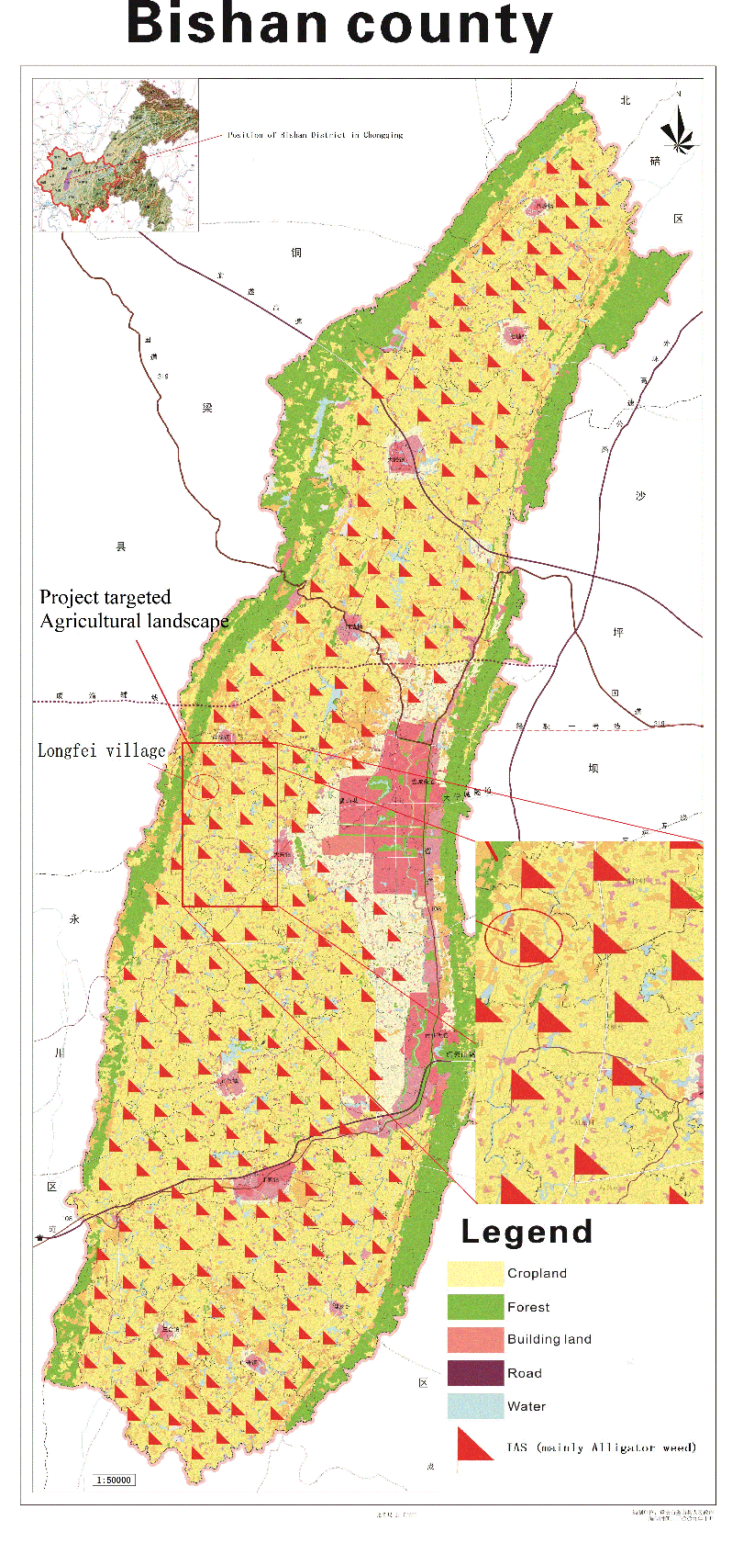
Although there is no data on village level of the estimated economic losses related to IAS, “back of the envelope” estimates are that the economic loss, of the occurrence of alligator weed and golden apple snail, costs the village (as a minimum) approximately 540,000 RMB per year, providing for a lost household income of 450 RMB. Together with the cost related to managing the IAS the overall cost at household level is at least 805 RMB and it could be much higher than this. In addition to this, it should also be taken into account that it is reported/indicated (through farmers interviews) that farmers spend approximately 50 man-days on IAS control and management a year.

IAS impact on biodiversity
With the inclusion of IAS into the national and provincial biodiversity strategies and action plans as well as into the agricultural and environmental five-year plans, China, at all levels, recognizes that IAS poses a substantial threat to the national biodiversity, as well as to the economy. However, it is difficult to identify direct species-related information, as to how various IAS are impacting them, including how IAS impact traditional varieties. For the PPG phase an attempt towards indicating the IAS impact on species (generally) was done for the Bishan District (Table 3) through ad hoc interviews with local farmers and district government staff.

IAS Management Training
While training on IAS Management is provided by the various government agencies, the village penetration is limited and is generally restricted to the areas, which are part of government programs/projects. In the recent years there has not been any form of agricultural technology training provided in Longfei, including on IAS Management. Based on the village consultations during the PPG phase some female villagers had however, taken part in four specialized women’s trainings on housekeeping related issues provided by the Chongqing Bishan District Human Resources and Social Security Administration, where a total of 47 women from the village attended training. During the village interviews local people expressed their willingness to participate in the project proposed village trainings, as they thought that it would contribute to the reduction of the impact of IAS on their agricultural production as well as improve their capacity to support the Government in the monitoring, prevention and control of IAS.
Figure 5:Wenchang and Hulu village agricultural landscape

Table 3: IAS’s influence on agricultural biodiversity.
Agricultural biodiversity | Invasive alien species (IAS)
Vegetables; corn and sweet potatoes | Alligator weed Alternanthera philoxeroides
Rice; wild rice stem and Snails (local) | Golden apple snail Pomacea canaliculata
Rice | Rice water weevil Lissorbqptrus oryzqphilus
Chinese spiny lobster | Red Swamp Crayfish Procambarus clarkii
Dark-spotted frog Pelophylax nigromaculatus and fish (local) | American bullfrog Rana catesbiana
Fish and Chinese spiny lobster Panulirus stimpsoni | Water hyacinth Eichhornia crassipes

Summary of Household survey
In Longfei Village a total of 121 people were surveyed (one per households). Of the total population surveyed, women accounted for 56% and men accounted for 44%. Age structure: 28% below 40 years of age, 40% of 41-60 years old, 32% above 60 years of age. 50% of the respondents had an education level of primary school or lower while 40% had obtained a junior high school level education. Only 10 % of the respondents had a high school diploma or higher. The proportion of villagers working outside the village accounted for 65%, while 35% can be considered professional farmers. About 40% of people working outside the village live abroad for a long time every year, while the remaining population return to their homes every day. All of the respondents belong different ethical groups other than Han.

Survey Summary
Financial Capital:
Household income, annual in 2017, RMB. | Longfei: 1 person is under 5000 yuan, 8 persons are 5000-10000 yuan, 7 person are 10000-15000 yuan, 11 persons are 15000-20000 yuan, 8 persons are 20000-25000 yuan, 3 persons are 25000-30000 yuan, 61 persons are 30000 yuan and above, and 22 persons’ annual household incomes are not clear.
Proportion of income deriving from Agriculture. | Longfei: 46 households’ agricultural income accounts for less than 25% of total household income, 32 households’ agricultural income accounts for 25% - 50% of total household income, 4 households’ agricultural income accounts for 50% to 75% of the total household income, 16 households’ agricultural income accounts for more than 75% of the total household income.
Household’s agricultural output. | Longfei: 98 households grow corn, with an average annual yield of 1000kg; 85 households planted wild rice stem, with an average annual yield of 2800kg; 70 households grow green vegetables heads, with an average annual output of 3000kg; 118 households harvested eggs, with an average annual yield of 260kg; 107 households harvest meat, with an average annual output of 200kg; 35 households harvest milk, the average annual output is 100kg; 60 households grow fruits, with an average annual output of 700kg.
Natural Capital:
Household’s access to farmland (mu). | Longfei –Among the investigated families, 55 households are with farmland land area 0-3 mu, 55 households with 3-6 mu land area, and 11 households with more than 6 mu farmland area. All the lands are collective land, no private land or rented land. On average, each household has a land area of 4.2 mu.
Main crops grown per household | Longfei –Corn has an average planting area of 1.8 mu per household. Wild rice stem has an average planting area of 1.2 mu per household. Green vegetables heads has an average planting area of 1.6 mu per household. Fruit has an average planting area of 1.5 mu per household.
Output of main crops per mu. | Longfei –On the collective lands, the average yield of corn is 150 kg/mu. The average yield of wild rice stem is 80 kg/mu. The average yield of green vegetables heads is 100 kg/mu. The average yield of fruit is 120 kg/mu.
Access to irrigation water resources: | Longfei –The main means of irrigation are canals and pumps, with an average of 1 pump per household. The main water source comes from tap water and underground water.
Use of Chemicals by households. | Longfei –The main types of fertilizer are chemical fertilizer (50%), organic fertilizer (20%) and compound fertilizer (30%).
Problems with invasive species (information per species): | Longfei: The main invasive alien species is alligator weed (Alternanthera philoxeroides). It happens in every household. The average economic loss is 400 yuan/mu·year. The main control measure is artificial spraying of herbicide. It requires 50 days of manpower input each year. The total cost of household management of IAS is about 300 yuan per year.
Physical Capital:
Agricultural equipment. | Longfei: 6% of households own large farm machinery, such as harvesters. All households are equipped with small agricultural equipment, such as pesticide boxes.
Vehicles. | Longfei: 20% of households own 1 car. 60% of households own motorbikes.
Livestock (indicate type and numbers): | Longfei: 80% of the households breed chickens, ducks, geese, etc. 25% of households breed cattle, sheep, etc.
Work day balance:
Respondent’s annual days worked in agricultural work: | Longfei: About 150 days per year for each professional farmer worked in agricultural work.
Respondents daily activities in hours: | Longfei: (average)  Work outside the home (6); Cooking (1); Child care (2); Other housework (1); School (2); Leisure time (8) and Other (4)
Other:
Membership in cooperatives, associations, etc.: | Longfei: 40% of the households joined the rural cooperatives.
Women or ethnic minority groups: | Longfei: Most of the people are ethnic minority.
Access to low interest credit: | Longfei: All households are aware of low interest credit and have (or could) obtained such credit.
Agriculture insurance: | Longfei: All households have some form of agricultural insurance.

Annex Q-2: Project targeted agricultural landscape in Hainan.

Wenchang City

Main features
Wenchang City is located in the northeast of Hainan Island by Wenchang River (Location E 108°21′~111°03′, N 19°20′~20°10′.). Wencheng City is a district level city, situated 63 km away from the provincial capital Haikou. The whole city area covers 2,403 square kilometers and has approximately 1.62 million mu of farming land. 640,000 mu of these are designated crops land, 560,000 mu are meadow and grassland and 410,000 mu are fallow, abandoned or otherwise underutilized lands, often referred to as wasteland. In addition, there are approximately 40,000 mu fresh water surface areas used for aquaculture. Wenchang City has tropical monsoon island weather pattern, with an annual average precipitation of 1529.8~1948.6 millimeters and an annual average temperature of 23.9℃. Rubber and coconut are the main products of Wenchan City where the total coconut output of the city accounts for nearly half of all of Hainan’s production. Cucurbits and vegetables are also main crops in Wenchang, as are marine and freshwater aquaculture products, which have substantial market shares.
Figure 6: Location of Hainan in China
Map 6: Hainan's location in China

Major IAS
Many of the main Alien Invasive Species, which are found in Hainan (Table 2) are also found in Wenchang City, such as mile-a-minute Mikania micrantha, alligator weed Alternanthera philoxeroides, water hyacinth Eichhornia crassipes, Siam weed Eupatorium odoratum and golden apple snail Pomacea canaliculate. Mile-a-minute, which seriously damages broad leaf wild kiwifruit, longan and litchi, as well as many traditional fruit tree cultivars, has developed in to a major threat to Hainan Province agricultural biodiversity and is now occurring on around 100,000 mu within Wenchang city. Golden apple snail is also a major threat, as it occurs in a similar large area (100,000 mu). The red imported fire ant Solenopsis invicta has infested over 80,000 mu, within its short time span of being present on the island.
Figure 7 Location of Wenchang City in Hainan

Public governance and institutional framework for IAS management
At provincial level the Agriculture Ecology and Resources Protection General Station of Hainan Province has the overall lead with regard to IAS monitoring and implementation of IAS prevention, control and management. It has 10 full-time administrative staff dealing with IAS, including 4 senior staff positions and 4 junior positions. The Wenchang City Agricultural Technology Promotion Service Center, which has the city level lead on IAS Management and is working together with other city level agencies (see table 1), spends 1.5 million RMB annually on invasive species prevention and control.
Map 7: Wenchang City's location in Hainan

Table 1 roles and responsibilities of government departments
Department / bureau / agency | Roles and responsibilities
Hainan Provincial Department of Agriculture (HPDA) | The Hainan Provincial Department of Agriculture is the provincial equivalent to MARA and undertakes many of the same functions but at provincial level. The Department of Agriculture is the provincial lead with regard IAS prevention, control and management.
Wenchang Agricultural Technology Promotion Service Center (WATPSC) | As part of the People's Government of Wenchang City the Wenchang Agricultural Technology Promotion Service Center is in charge of providing agricultural production service and technical promotion of Wenchang City and is responsible for the implementation of IAS prevention, control and management at local level.
Wenchang Forestry Bureau (WFB) | As part of the People's Government of Wenchang City the Wenchang Forestry Bureau is in charge of forestry management in Wenchang City including the implementation of IAS prevention, control and management at local level within the forested areas of Wenchang.
Wenchang Eco-environmental Protection Bureau (WEPB) | As part of the People's Government of Wenchang City the Wenchang Eco-environmental Protection Bureau is in charge of ecological environment protection in Wenchang City and is responsible for the implementation of IAS prevention, control and management within protected areas and other conservation areas.
Wenchang Finance Bureau | In charge of the allocation and use of financial funds in Wenchang City, responsible for the implementation of IAS prevention and control work.
Agricultural Technology Center of Donglu Township | In charge of the implementation of IAS prevention and control work in Donglu township.
Hulu Village | In charge for the implementation of IAS control and prevention at village level.

While the Wenchang City Agricultural Technology Promotion Service Center works through its 17 local township government institutions, the practical implementation of IAS Management is however, left to the village level governments/authorities, which engage the local farmers in projects/programs (which are part of provincial level programs with provided respective funding). Activities under such projects are different from the day-to-day interventions performed by the local farmers in their regular work on the fields which includes weed and pest management.

IAS management
While Wenchang is implementing Provincial plans and programs (as relevant) within its area, it does not have as such its own city IAS management system and so far no specific IAS Management planning has been formulated. The lack of systematic collection of information on IAS and respectively of a thorough and updated IAS county level list results in a poor information basis to support any future planning and management processes within the district. Some of the more aggressive IAS such as mile-a-minute, alligator weed, golden apple snail, red imported fire ant and water hyacinth have been subjects of relatively recent investigations throughout the entire district. These investigations, however, are most often based on a present/non-present methodology at village or field level. And as they are being undertaken every 3-5 years on a rolling basis the collected information is not “real-time” sensitive.

Table 2: Encroachment data of key IAS in Hainan Province

Key IAS found in Hainan Province | IAS affected area in  Hainan (mu) | IAS affected area in Wenchang (mu)
Alligator weed Alternanthera philoxeroides | 332,000 | 35,000
Water hyacinth Eichhornia crassipes | 1,500,000 | 200,000
Mile-a-minute Mikania micrantha | 1,350,000 | 130,000
Golden apple snail Pomacea canaliculata | 715,000 | 75,000
Water lettuce Pistia stratiotes | 260,000 | 30,000
Giant African Land Snail Achatina fulica | 165,000 | 15,000
Oriental Fruit Fly Bactrocera dorsalis | 225,000 | 20,000
Coconut leaf beetle Brontispa longissima | 3,260,000 | 300,000
Red imported fire ant Solenopsis invicta | 360,000 | 30,000
Cotton white fly Bemisia tabaci | 1,550,000 | 150,000
Rice water weevil Lissorhoptrus oryzophilus. | 56,000 | 5,000
Total | 9,773,000 | 990,000

Hulu agricultural landscape

Main Features
The project’s targeted agricultural landscape in Wenchang City, Hainan is located around the Hulu Village. Hulu village (map 8) itself is located in Donglu township 46 kilometers north west of Wenchang (main city). Since the village has the shape of a cucurbit, it is named after it. Hulu Village is composed of 10 natural villages and has a population of 2130 inhabitants, living in 560 households, with an average annual income of 13,500 RMB (please see Annex F and K for further socio/economic and gender related data). The village area is 6,035 mu of which cultivated land accounts for approximately 3500 mu divided in 500 mu garden/farming plots, 2800 mu woodland (also used for orchards), 250 mu of meadows and grassland, and in addition 20 mu of open water area. The main crops within the agricultural landscape are rice, pepper, peanut, winter melon, vegetables and sweet potato, but villagers also engage in planting and harvesting litchi, longan and Areca palm. The reported average yield of rice, vegetables, fruits and peanuts are 200, 170, 150 and 130 kg/mu respectively.
Figure 8: Location of Hulu village in Wenchang City
Map 8: Hulu village's location in Hainan

It is worth mentioning that Hulu Village has jack fruit trees, which are over hundred years old, litchi trees, which are over 300 years old and Poison Arrow Trees Antiaris toxicaria that are over 400 years old. Furthermore, close to the village is located a United Nations wild rice reserve, as well as several litchi plantations and a lotus ornamental garden.

Major IAS and current management approaches
In Hulu village one of the main IAS is mile-a-minute, which occurs in large areas (1,000 mu) within both the field system and public land and common-used areas of the village. In the PPG field survey 70% of the respondents reported that mile-a-minute affects their fields. Golden apple snail, which occurs on 400 mu affects 88% of the village households. In addition, siam weed is found on 500 mu within Hulu village area and alligator weed is found on approximately 100 mu.

The general IAS management measures applied by the villagers and farmers in combatting mile-a-minute fail to eradicate it due to its rapid growth, large seed production and ability to vegetative regenerate from cut-offs which leads to a rapid recolonization of cleared areas. Another key reason for the lack of effective removal of mile-a-minute is farmers’ restricted focus on the IAS when it occurs only in or around their fields, and lack of engagement, to any larger extent, in combatting mile-a-minute in the common-use areas outside immediate vicinity of the farm/forest plots. Also, there is no coordination among farmers in their efforts to contain the spread of the mile-a minute. The cost of controlling mile-a-minute (which is usually being done through manual removal) annually is approximately 450 RMB/mu, equating to 450,000 RMB per year for the affected areas, which equals to an average annual village household cost of approximately 800 RMB. Within the 24,000 ha large project target agricultural landscape around Hulu village alligator weed, mile-a-minute and golden apple snail can be found on respectively 3,500 ha, 13,500 ha and 7,500 ha. In addition, wild rice and wild litchi grows on approximately 100 ha and cultivation of these are undertaken on 2,500 ha.

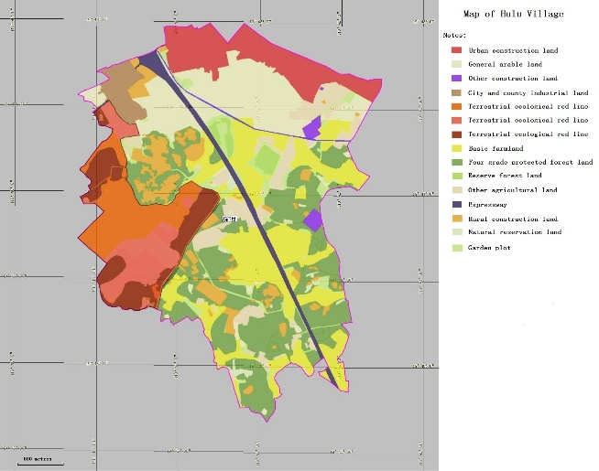
The farmers’ approach towards controlling the golden apple snail is similar to that in Longfei village (Chongqing), where free ranging ducks are used to predate on eggs and young snails. Pomelo oil is also used as a prevention measure, although not deemed very effective and as in Longfei the villagers, in cases of heavy infestation, mechanically (by hand) remove the snails. None of these generally used methods are aimed at eradicating the IAS but merely to control their numbers and keep them at an acceptable level.
Map 9; Landscape profile of Hulu village
Figure 9: Agricultural landscape around Hulu village

Rice paddies and other open water sources, which are affected by the golden apple snail, are also impacted by water hyacinth, and while spraying is on occasion used to control the IAS, the most common management measure is the mechanical removal of the specie. However, as the water hyacinth has a rapid vegetative regrowth, from even the smallest cut-off, such mechanical removal often facilitates the spread of the specie, or does little to halt it, and cleared areas are rapidly recolonized. The general cost of removal of water hyacinth is estimated at 450 RMB/mu, similar to the cost of mile-a-minute, and both are largely dependent on the labor cost associated with the manual removal of the IAS. There is not clear estimate of the area coverage of water hyacinth.

Economic losses from IAS encroachment
Although there is no data on village level of the estimated economic losses related to IAS, rough estimates are that the economic loss of the occurrence of mile-a-minute, water hyacinth and golden apple snail amounts as a minimum to approximately 500,000 RMB per year or a lost income per household of 895 RMB. As the PPG interviews and surveys only provided partial information on the management cost of controlling IAS in the village (i.e. data is only available for mile-a-minute), it is difficult to make an estimate but the total cost at household level, related to IAS would be at least 1695 RMB and it would most certainly be higher than that. It should also be taken into account that farmers report/indicate (through farmers interviews) approximately 60 man-days spent on IAS control and management a year.

IAS impact on biodiversity
Recognizing the substantial threat IAS pose to the national biodiversity and also to the economy, China has included IAS into the national and provincial biodiversity strategies and action plans as well as into the agricultural and environmental five-year plans. However, it is difficult to identify direct species-related information as to how various IAS are impacting them, including how IAS impact traditional varieties. For the PPG phase an attempt towards indicating the IAS impact on species (generally) was done for the Wenchang City (Table 3) through ad hoc interviews with local farmers and district government staff.

Table 3: IAS’s influence on agricultural biodiversity
Agricultural biodiversity | Invasive alien species (IAS)
Vegetables | Alligator weed Alternanthera philoxeroides
Litchi | Mile-a-minute Mikania micrantha; Siam weed eupatorium odoratum
Fish (local) | Water hyacinth Eichhornia crassipes
Areca palm | Mile-a-minute Mikania micrantha,
Longan | Mile-a-minute Mikania micrantha; Siam weed eupatorium odoratum
Peanut | Alligator weed Alternanthera philoxeroides; Mile-a-minute Mikania micrantha; Siam weed eupatorium odoratum
Rice | Golden apple snail Pomacea canaliculate;

IAS Management Training

Although various government agencies provided trainings on IAS Management, the outreach in the the villages is limited and is generally restricted to the areas which have been included in government programs/projects. In the recent years no training on agricultural technology nor on IAS Management (nor any kind of training on any topic), has been offered to the farming community of Hulu. However, during the village interviews local people expressed their willingness to participate in the project proposed village trainings.

Summary of Household survey
In Hulu Village a total of 46 people were surveyed (one per households). Of the total population surveyed, women accounted for 58% and men accounted for 42%. Age structure: 25% below 40 years of age, 45% of 41-60 years old, 30% above 60 years of age. 40% of the respondents had an education level of primary school or lower while 40% had obtained a junior high school level education. A total of 20 % of the respondents had a high school diploma or higher. The proportion of villagers working outside the village accounted for 60%, while 40% can be considered professional farmers. About 32% of people working outside the village live abroad for a long time every year, while the remaining population return to their homes every day. 44 people belong to Han ethical groups, 2 people belong to ethical groups

Survey Summary
Financial Capital:
Household income, annual in 2017, RMB. | Hulu: 5 person is under 5000 yuan, 15 persons are 5000-10000 yuan, 11 person are 10000-15000 yuan, 7 persons are 15000-20000 yuan, 5 persons are 20000-25000 yuan, 2 persons are 25000-30000 yuan, 1 persons are 30000 yuan and above.
Proportion of income deriving from Agriculture. | Hulu: Among the 46 households surveyed, 25 households’ agricultural income accounts for less than 25% of total household income, 8 households’ agricultural income accounts for 25% - 50% of total household income, 2 households’ agricultural income accounts for 50% to 75% of the total household income, 2 households’ agricultural income accounts for more than 75% of the total household income; and 22 persons’ agricultural income ratios are not clear.
Household’s agricultural output. | Hulu: 31 households grow peanuts, with an average annual yield of 150kg; 40 households grow rice, with an average annual yield of 300kg; 26 households grow vegetables, with an average annual output of 500kg; 28 households harvested eggs, with an average annual yield of 100kg; 16 households harvest meat, with an average annual output of 60kg; 19 households grow fruits, with an average annual output of 160kg
Natural Capital:
Household’s access to farmland (mu). | Hulu–Among the investigated families, 10 households are with farmland land area 0-3 mu, 23 households with 3-6 mu land area, 13 households with more than 6 mu farmland area. All the lands are collective land, no private land or rented land. On average, each household has a land area of 5.3 mu.
Main crops grown per household | Hulu –Peanuts has an average planting area of 1.1 mu per household. Rice has an average planting area of 2 mu per household. Vegetables have an average planting area of 1.2 mu per household. Fruit has an average planting area of 1.4 mu per household.
Output of main crops per mu. | Hulu –On the collective lands, the average yield of peanuts is 130 kg/mu. The average yield of rice is 200 kg/mu. The average yield of vegetables is 170 kg/mu. The average yield of fruit is 150 kg/mu.
Access to irrigation water resources: | Hulu –The main means of irrigation are canals and pumps, with an average of 0.5 pumps per household. The main water source comes from tap water and underground water.
Use of Chemicals by households. | Hulu –The main types of fertilizer are chemical fertilizer (70%) and organic fertilizer (30%).
Problems with invasive species (information per species): | Hulu: The main invasive alien species are apple snail (Pomacea canaliculata) (occurred in 88% households) and mile-a-minute (Mikania micrantha) (occurred in 70% households). The average economic loss is 360 yuan/mu·year. The main control measures are artificial clearance (for apple snail) and artificial spraying of herbicide (for apple snail and mile-a-minute). It requires 60 days of manpower input each year. The total cost of household management of IAS is about 450 yuan per year.
Physical Capital:
Agricultural equipment. | Hulu: 35% of households own large farm machinery, such as tractors and harvesters. All households are equipped with small agricultural equipment, such as pesticide boxes.
Vehicles. | Hulu: 30% of households own 1 car. 80% of households own 1 or more motorbikes.
Livestock (indicate type and numbers): | Hulu: 90% of the households breed chickens, ducks, geese, etc. 30% of households breed cattle, sheep, etc.
Work day balance:
Respondent’s annual days worked in agricultural work: | Hulu: About 220 days per year for each professional farmer worked in agricultural work.
Respondents daily activities in hours: | Hulu: (average)  Work outside the home (6.5); Cooking (1); Child care (1.5); Other housework (1.5); School (2); Leisure time (8.5) and Other (3)
Other:
Membership in cooperatives, associations, etc.: | Hulu: 80% of the households joined the rural cooperatives.
Women or ethnic minority groups: | Hulu: Only a few people are ethnic minority.
Access to low interest credit: | Hulu: All households are aware of low interest credit and have (or could) obtained such credit.
Agriculture insurance: | Hulu: All households have some form of agricultural insurance.
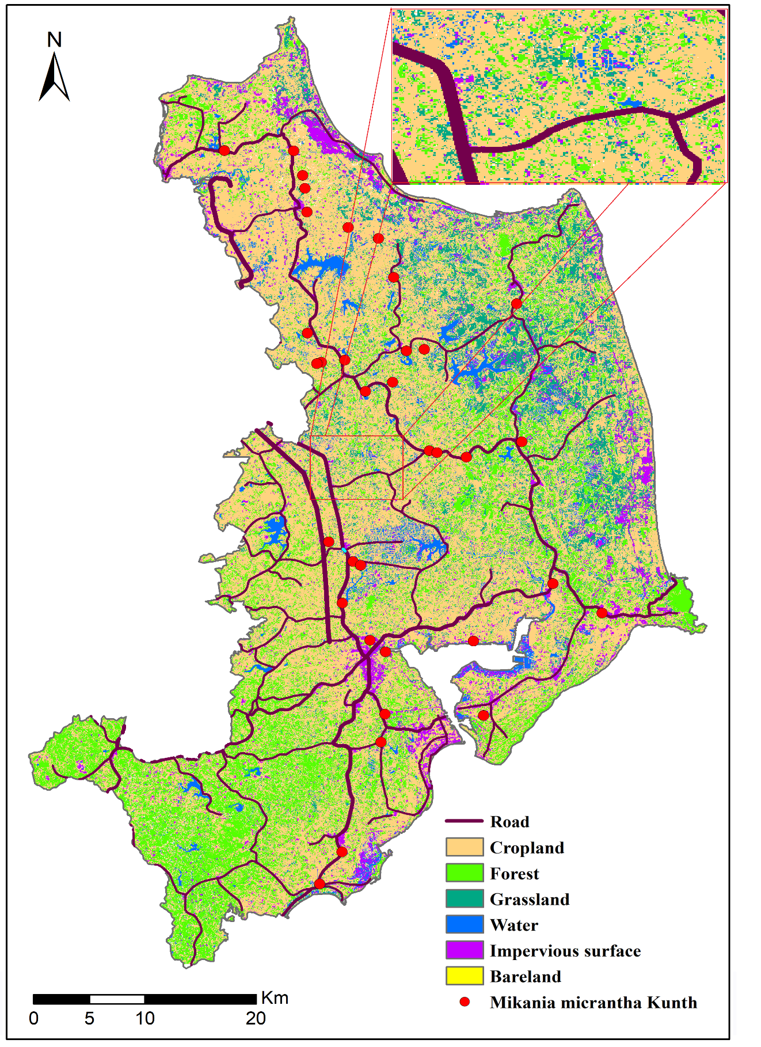
Figure 10: Wenchang and Hulu village agricultural landscape

1 mu=1/15 ha

